Hi All

In my lab today three teams successfully set up their master repositories but two of them had the same problem.

When they entered the password to connect Visual Studio to GitHub and upload their skeleton code there was an error stating the repository could not be found.

This is almost certainly due to a miss typed git password and or username

To fix this the solution needs to be taken out of source control.

The simplest way to do this is to delete the configuration files from the solution’s folder.

- Quit Visual Studio
- Open the folder containing the solution and projects
- In the Windows tool bar make sure Hidden Items is ticked

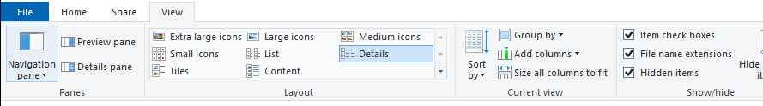

You should see the following files and folders listed...
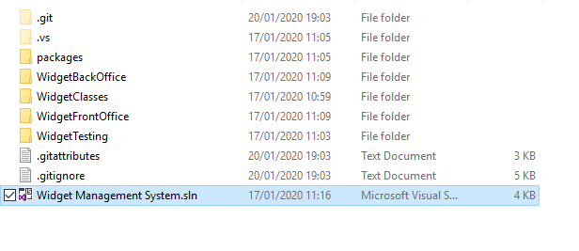
- Delete the .git folder and the two .git files
- Double click the sln file to get back into Visual Studio (The solution should now be removed from source control) try adding to source control again
- If that still doesn’t work then repeat the process above but before trying step 5 make sure the password and username for GitHub are being entered correctly
- If still in doubt try changing the GitHub password and try again

Regards

Matthew

